

Task 2 – Pass Submission

Student Number: Truong Ngoc Gia Hieu
Student Name (VietNam/Australia): SWS01217/ 105565520

Task Pass3a
Firstly, I had to download named MOVIEDB_SQL-1.txt and opened it in a text editor such as Notepad. Then, I need to replace all occurrences of XXXX with my student ID's last 4 digits (5520) across the tables, and finally saved the changes.
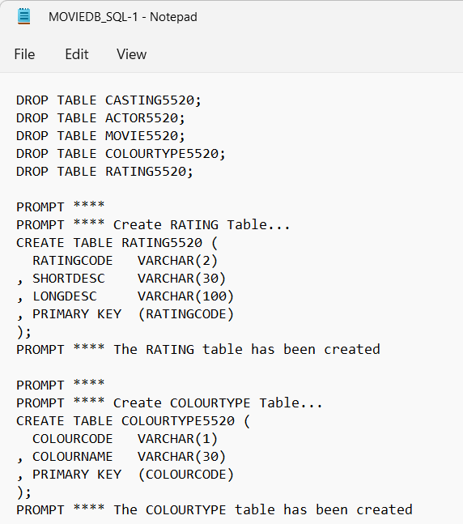
Figure 1: Updating SQL script with student ID 5520

